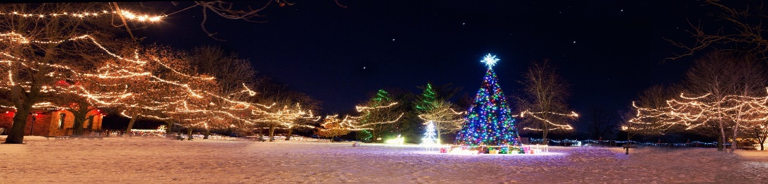

5th Annual Quarryville Borough
“Merry & Bright” Light Display Contest
2 Categories:
Residential
Commercial
(Residential: prizes will be awarded as follows, 1st, 2nd, 3rd, Griswold Award, Vintage/Classic Award, Judges Honorable Mention
and Most Creative)
(Commercial: One trophy will be awarded to the best business display w/ bragging rights for the whole Year!!)

Register by emailing evansm@quarryvilleborough.com or call our office at 717-786-2404 final day to register is December 5th.
Judging will be Thursday night December 18th with a snow date of Friday night December 19th. Winners will be announced Monday, December 22nd.

All displays must be appropriate for viewing by all ages. Please no political messages. We reserve the right to disqualify. Digital photos will be taken of the winners displays and we reserve the right to use these photos for public purposes. This contest is for Quarryville Borough residents only.

