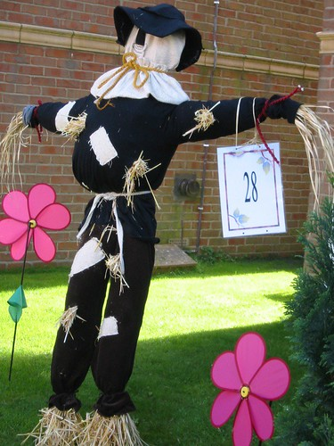

Quarryville Borough Residents Scarecrow Decorating Contest
Register to enter this contest by email to: evansm@quarryvilleborough.com by September 30th.
Please give your name, address, phone & category.
All scarecrows must be hand-made (no store-bought scarecrows allowed).
**A wooden frame is available free of charge by request. **
Categories include:
Most creative
Cartoon/book/movie characters
First responders
Historical figures
This contest is for Quarryville Borough residents only.
All scarecrows must be suitable for public viewing of all ages. No lewd, graphic, violence or gore. We reserve the right to disqualify. Digital photos will be taken of your design and we reserve the right to use these photos for public purposes.
Judging will be October 11th, 2024.
Raindate of October 18th, 2024

