
LAKES APPRECIATION MONTH EVENT – Saturday July 29, 2023 From 2:00 p.m. – 6:00 p.m.

July is Lakes Appreciation Month!
You work and play on them. You drink from them. But do you really appreciate them? Growing population, development, and invasive species stress your local lakes, ponds, and reservoirs. All life needs water; let’s not take it for granted!
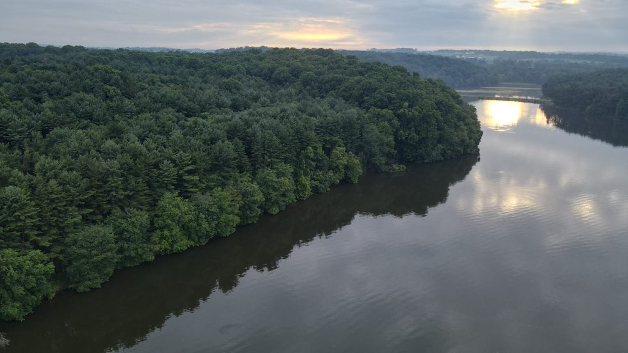
2022 INAUGURAL LANCASTER COUNTY LAKES APPRECIATION MONTH EVENT VIDEO
The inaugural 2022 Lancaster County Lakes Appreciation Month Event was initiated and organizationally coordinated by PFBC District Officer J. Schmidt and sponsored by Chester Water Authority owners of the 642-acre Octoraro Reservoir http://chesterwater.com/fishingbrochure.pdf event venue along with Gina & Jim Neary who manage the Reservoirs recreational fishing and boating access. Conservation organizations to include the:

The mission of the Octoraro Watershed Association is to restore and protect the natural resources of the scenic Octoraro Creek and to preserve and protect its farmlands, forest, and rural heritage through education, outreach, restoration, and community stewardship. For more to include membership link to: www.theowa.org
 providing wild and forested lands and clean waterways for our community forever. https://www.lancasterconservancy.org/preserves/octoraro-creek/ among others will staff educational exhibits.


“For over 35 years, the Chesapeake Bay Foundation has been working in Pennsylvania to restore and protect local rivers and streams. The staff from the Harrisburg office works with farmers and property owners to reduce the amount of polluted runoff that enters local waters from agriculture, urban and suburban stormwater, and other sources. They also do this by coordinating the Keystone 10 Million Trees Partnership.” CHESAPEAKE BAY FOUNDATION


The Lancaster County Conservation District advances conservation practices and encourages responsible stewardship to preserve our natural resources. The Watershed Department will have an interactive activity on macroinvertebrates and stream health as well as educational publications. https://www.lancasterwatersheds.org/
 CLEAN & CLEAR BY 2040
The Lancaster Clean Water Partners brings together a diverse group of partner organizations – local leaders in business, municipal, public service, higher education, conservation planning, and non-profit management – with a shared vision of clean and clear water in Lancaster County by 2040. The Lancaster Clean Water Partners’ mission is to rapidly accelerate and expand the ability of partner organizations to restore and sustain Lancaster’s waterways. https://lancastercleanwaterpartners.com/

er Partners’ mission is to rapidly accelerate and expand the ability of partner organizations to restore and sustain Lancaster’s waterways.

Lancaster Clean Water Partners’ mission is to rapidly accelerate and expand the ability of partner organizations to restore and sustain Lancaster’s waterways.

Penn State Extension Master Watershed Stewards are community volunteers that work to improve the health of our streams, rivers, and other natural resources. The Stewards will have an educational booth on Aquatic Invasive Species. They will also have aquatic insects to show and tell. Master Watershed Steward Program (psu.edu)
 The Pennsylvania Fish & Boat Commission as well as the Pennsylvania Game Commission will staff educational exhibits providing complimentary agency publications of both a regulatory and safety nature. The PFBC will be accompanied by a cadre of native reptiles and amphibians. Representative of the Commissions role in protection of native reptiles and amphibians “on hand” will be “Deputy B.R. Snake’” a mature Eastern Rat Snake and his patrol sidekick “Mr. X-BOX Turtle.”
The PGC will display their Operation Game Thief educational trailer. https://www.pgc.pa.gov/HuntTrap/Law/Pages/OperationGameThief.aspx
The Southern Lancaster County Farmer’s Sportsman’s Association https://www.slcfsa.org/conservation/ a PFBC Cooperative Nursery since 1968 will exhibit and inform attendees as to Club supplemental trout stocking in the Octoraro Watershed.
 Stroud Water Research Center's mission is to advance knowledge and stewardship of freshwater systems through global research, education, and watershed restoration. The SWRC educational exhibit will have information about the center and how you can help improve the health of our lakes and streams. They will also have activities such as water chemistry, and water sampling of the Octoraro Reservoir. Home (stroudcenter.org)

 The Federal EPA is currently funding two projects to support local partnerships to restore the water quality. The first is development of a water quality model that will support watershed management. The second is a 3–5-year strategic plan for the Octoraro Source Water Collaborative. Source water refers to the surface or groundwater that is used for drinking water. In this case the Octoraro Reservoir. Impaired Waters and TMDLs in Region 3 | US EPA

Local independent agricultural, engineering and consulting services consulting firm Team Ag will showcase projects in the Octoraro Watershed and educate attendees as to initiatives to protect water quality. TeamAg Inc | Search Results Octoraro Watershed
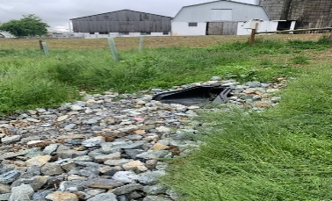 A farm project along Valley Run, a tributary to the Octoraro Creek. The Alliance For The Bay funding TeamAg installation of a new barnyard and manure storage, while redirecting clean stormwater to a newly planted riparian buffer.

"The Chester Water Authority has partnered with TeamAg to develop, update, and maintain nutrient management plans in addition to providing engineering services when needed, at no cost to farmers. Our work aims to support farmers in their efforts to reduce and prevent sediment and nutrient runoff from entering the Octoraro Reservoir."
The United States Coast Guard Auxiliary – Flotilla 19-4 will be conducting Vessel Safety Courtesy checks from 2:00 p.m. – 6:00 p.m.to aid boaters with their knowledge of requisite boating safety equipment inclusive of both powered and unpowered vessels. Welcome to the Flotilla 19-4, District 5NR Web Site (uscgaux.info)
http://cgaux.org/vsc/
 The Oxford Library will highlight a selection of event thematic books for both youth and adult readers. oxfordpubliclibrary.org

Food trucks will be on hand, and a complimentary sampling of grilled snakehead the aquatic invasive fish that has been identified in the reservoir will be offered. NORTHERN SNAKEHEAD - FILET DEMONSTRATION - MARYLAND DNR
First Snakeheads Caught in Pa. Creek off Susquehanna ...
https://chesapeakebaymagazine.com › Bay Bulletin
Sep 19, 2018 — The Octoraro snakeheads appear to have traveled north on their own and were caught below the Octoraro Reservoir. The threatened Chesapeake ...
Dreaded 'Frankenfish' arrives in Lancaster County | Outdoors
https://lancasteronline.com › sports › dreaded-frankenfish...
July15, 2018 — Mark Mabry of Gap holds Lancaster County's first confirmed northern snakehead that he caught in Octoraro Creek in Little Britain Township on ...

Sponsor & host Chester Water Authority will provide bottled water and iced tea, plus individually wrapped soft pretzels and pretzel dogs from Philly Pretzel Factory.
This family friendly event will feature a catch & release containment Fish Pond for Jr. anglers age 12 and under to fish for Blue Gill & Lunker Largemouth Bass. Rods will be provided, or kids bring your favorite superhero bait caster with barbless hooks. barbless hooks


The day’s commerative educational event will culminate in a “Full Moon” Paddle the second ever at sunset paddling event permitted on the Octoraro Reservoir, registration is limited via https://www.jimsbait.net/
The Moon phase for July 29th, 2023 is a Waxing Gibbous phase. This is the phase where the moon is more than 50% illuminated but has not yet reached 100% illumination (which would be a Full Moon). In the Northern Hemisphere, the right side will be illuminated. On this day, the moon is 11.9 days old and 87.16% illuminated with a tilt of 122.591°. The approximate distance from Earth to the moon is 367,994.86 km and the moon sign is Sagittarius.
Safety Stipulations Will Be Stringent.
Safety Briefing/Check At 8:00 P.M. – Launch At 8:20 – Sunset At 8:31 p.m.
- Paddle Event Will Be Conducted As An Organized “Aquaborne Flotilla”
- Safety Lead – Conewago Canoe & Kayak Club CONEWAGO CANOE & KAYAK CLUB
- All Boats Off The Water By 9:45 P.M.
- All Paddlers To Be Donned In A U.S.C.G. Approved PFD [Properly Fitted] W/Whistle Attached
- All Paddlers To Have A Flashlight Or Wear A Headlamp
Consider Crafting Your Own “Lume Stick” or wearing a Green or Red cyalume stick on your PFD. https://www.youtube.com/watch?v=rY6gWBZglyc
https://clarifygreen.com/environmentally-friendly-alternative-to-glow-sticks/

